https://www.canva.com/design/DAFinxSS-HM/E_wrxjEPxFTGDyOhYEMNGQ/edit?utm_content=DAFinxSS-HM&utm_campaign=designshare&utm_medium=link2&utm_source=sharebutton

INDUSTRIAL TRAINING’S FINAL REPORT

PREPARED BY

AKHTAR NUR AFIF BIN RAMZI

05DDT20F1028

AT

ANALOG DEVICES SDN. BHD.

PLOT 21(B), PHASE 4

BAYAN LEPAS FREE INDUSTRIAL ZONE

11900 BAYAN LEPAS

PULAU PINANG

MALAYSIA

This report is submitted to Information Technology Department as partial fulfillment of the requirement for the Award Diploma in Information Technology (SOFTWARE & APP DEVELOPMENT)

POLITEKNIK KUCHING SARAWAK

JUN 2023

LIST OF CONTENT

CHAPTER 1: INTRODUCTION

* 1. Introduction

Internships have become an increasingly vital component of the modern job market, serving as a gateway for students, recent graduates, and career changers to enter the workforce. They offer a unique and immersive experience that goes beyond the classroom, providing individuals with invaluable practical knowledge and skills necessary for their chosen fields.

One of the primary advantages of pursuing an internship is the opportunity to bridge the gap between academic learning and professional practice. While classroom education equips individuals with theoretical foundations, internships enable them to apply that knowledge in real-world scenarios. By actively engaging in hands-on projects, tasks, and assignments, interns gain practical experience that enhances their understanding of industry-specific processes and dynamics.

Moreover, internships provide a structured learning environment where individuals can receive guidance, mentorship, and feedback from experienced professionals. Working closely with mentors and supervisors allows interns to develop critical thinking, problem-solving, and decision-making skills. They also have the chance to witness firsthand how professionals tackle challenges, collaborate with colleagues, and navigate through various work scenarios.

Internships are not only about acquiring technical skills; they also foster the development of essential soft skills. Effective communication, teamwork, adaptability, and time management are just a few examples of the skills interns can cultivate during their internship experience. These skills are highly sought-after by employers and are transferable across various industries, contributing to the overall professional growth and employability of individuals.

Networking is another significant advantage of internships. Interns have the opportunity to connect with professionals in their chosen field, establishing valuable relationships that can lead to future job opportunities. Engaging with industry experts, attending company events, and participating in networking activities allows interns to expand their professional network and gain insights into different career paths and prospects.

Internships come in various forms, including summer internships, semester-long programs, co-op opportunities, and apprenticeships. Some internships may be paid, while others offer academic credit or stipends. The duration and structure of internships can also vary, allowing individuals to choose the option that best aligns with their academic commitments and career goals.

In conclusion, internships play a pivotal role in providing individuals with a practical and immersive learning experience, bridging the gap between education and the professional world. By offering hands-on opportunities, mentorship, skill development, and networking prospects, internships prepare individuals for successful careers in their desired fields. They serve as a crucial stepping stone towards professional growth, job market competitiveness, and personal fulfillment.

CHAPTER 2: COMPANY BACKGROUND & ORGANIZATION STRUCTURE

2.1 Analog Devices Background

Analog Devices, Inc., also known as ADI or Analog, is an American multinational semiconductor company specializing in data conversion and signal processing technology, headquartered in Norwood, Massachusetts. The company manufactures analog, mixed-signal and digital signal processing (DSP) integrated circuits (ICs) used in electronic equipment. These technologies are used to convert, condition and process realworld phenomena, such as light, sound, temperature, motion, and pressure into electrical signals.

Analog Devices has approximately 100,000 customers in the following industries: communications, computer, industrial, instrumentation, military/aerospace, automotive, and consumer electronics applications. Analog Devices has regional headquarters located in Shanghai, China; in Munich, Germany; Limerick, Ireland; and Tokyo, Japan. Analog Devices has fabrication plants located in the United States and in Ireland. The company's testing facility is located in the Philippines. Design centers are located in Australia, Canada, China, England, Germany, India, Israel, Japan, Scotland, Spain, Taiwan and Turkey.

In July 2016, Analog and Linear Technology agreed that Analog would acquire Linear in an approximately $14.8 billion cash and stock deal.

Linear Semiconductor Sdn Bhd, a wholly owned subsidiary of Linear Technology Corporation, was established as its only Assembly Manufacturing factory in Penang in October 1994. Linear Semiconductor Sdn Bhd, Penang manufactures a wide range of semiconductor packages, inclusive of Mini-SO package (MSOP), Quad Flat Non-Leaded package (QFN/DFN), Thin Shrink Small Outline package (TSSOP) in various configurations and also the thicker SSOP version, Small Outline package (SO), Plastic Dual-In-line (PDIP) and Transistor Outline package (TO220/DD Pak), Micro-modules etc. The company also has its own testing facility in Penang. The company now employs about 1700 workers all of which are locals. The size of the plant grown from 25,000 Sq. Ft. to over 125,000 Sq. Ft. of production area in the last 20 years. ​

2.1.1 Company Profile

|  |  |
| --- | --- |
| Name | Analog Devices Sdn Bhd |
| Address | Plot 21(B), Phase 4 Bayan Lepas Free Industrial Zone 11900 Bayan Lepas Pulau Pinang Malaysia |
| Telephone | 60-4-6151000, 04-615 1000 |
| Email |  |
| Website | [http://www.analog.com](http://www.analog.com/) |
| Career Website | [https://careers.analog.com](https://careers.analog.com/) |
| Career Email |  |
| Areas of Specialization | * Engineering - Electrical / Electronics * Engineering - Mechanical * IT - Software * Manufacturing |

2.2 Organization Chart

2.2.1 Department IT

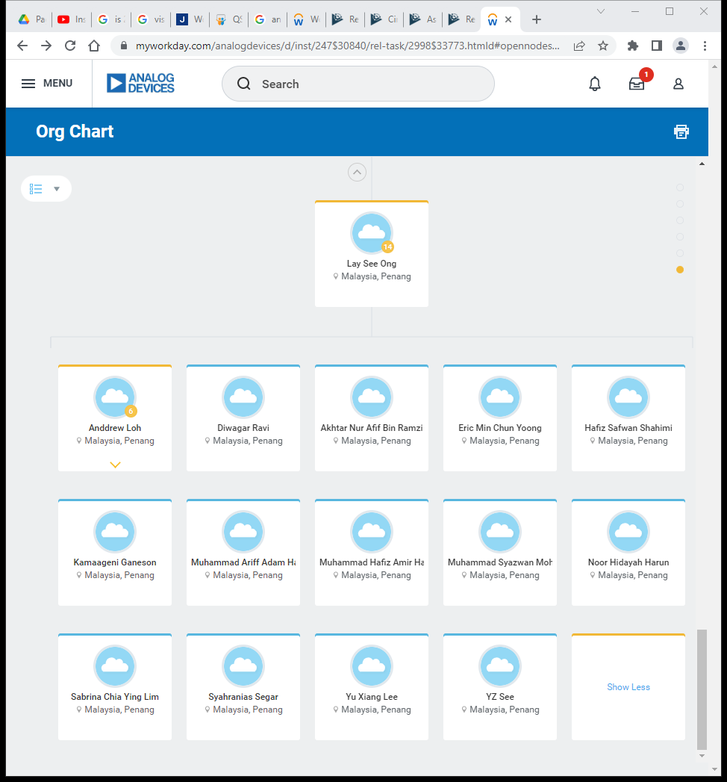

2.2.2 Whole Organization Chart

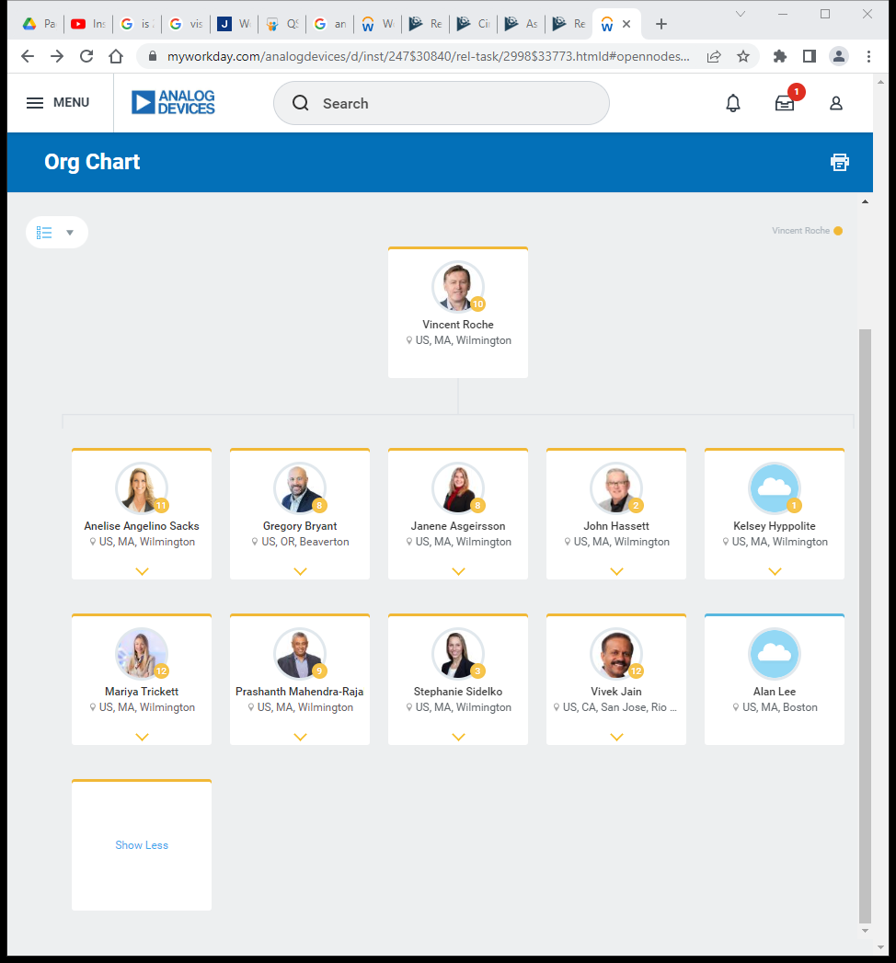

2.3 Vision and Mission

2.3.1 Vision

Our vision is for employees to unlock their collective potential by harnessing the power of their unique perspectives. Together, they spark provocative questions, generate unexpected insights, and bring to life innovative solutions that change the world.

2.3.2 Mission

For decades, Analog Devices has built bridges between the physical and the digital. Our products transform complex real-world signals into the insights and actions that can shape the future and improve the world around us.The digital acceleration is happening at an almost incomprehensible pace. Sometimes we forget that the digital world exists only to better understand our relationship to the real world. The digital world helps us capture and interpret what the real world is telling us. It creates opportunities to use these insights and actions to engineer good.

* Transforming healthcare for better access and outcomes
* Unlocking human potential by safely automating factories and transportation
* Combating climate change through electrification, energy management and industrial efficiency
* Connecting humanity to foster knowledge, understanding and community

CHAPTER 3: WEEKLY JOBS SUMMARY

|  |  |  |
| --- | --- | --- |
| Date | Week | Activity summary |
| 30th January 2023 -  3rd February 2023 | 1 | * Orientation * Learn Cron-Tab and Cron-Job * Learn Linux Command and directory structure * Learn Types and Spec of Workstation * Meeting- Production briefing |
| 6th February 2023 –  10th February 2023 | 2 | * Complete courses * Install and Setup of VM Virtual Box and Redhat * Learn Perl Programing language * Complete beginner Perl programming language project |
| 13th February 2023 –  17th February 2023 | 3 | * Briefing new flask project * Learn Python * Complete beginner Python programming language project * Learn and deploy “Hello World” using Framework called Flask * Flask project- started |
| 20th February 2023 - 24th February 2023 | 4 | * Learn function to extract data from excel to database * Learn generate report in any format * Flask project- changes(database) * Flask project- add function (extract excel to database) * Flask project- add function (generate report in excel) |
| 27th February 2023 -  3rd March 2023 | 5 | * Learn securing Flask app * Production task- Backup and restore hardstuck |
| 6th March 2023 -  10th March 2023 | 6 | * Solving Error Xampp * Flask project- database changes * Flask project- Add Css |
| 13th March 2023 -  17th March 2023 | 7 | * Solving Error Visual Studio code * Flask project- Add login page * Learn Flask logout |
| 20th March 2023 -  24th March 2023 | 8 | * Flask project- Add logout * Review Flask project * Learn Batch File(BAT) |
| 27th March 2023 -  31st March 2023 | 9 | * Study Perl Programming Language * Perl language basic project (BMI calculator, Calculator and Password generator) |
| 3rd April 2023 -  7th April 2023 | 10 | * Flask project- Add cancel button * Flask project- improving on popup * Learn Perl language- standard includes * Learn Perl language- copy and move file to new directory |
| 10th April 2023 -  14th April 2023 | 11 | * Learn Perl scripting * Join ADI raya contest * Learn debugging |
| 17th April 2023 -  21st April 2023 | 12 | * Flask Project- improving styling Excel * Learn useful command from Industry’s website |
| 24th April 2023 -  28th April 2023 | 13 | * Learn resolve RasPi not responding |
| 1st May 2023 -  5th May 2023 | 14 | * Learn configure NVRAM * Flask project- increment and decrement * Flask project- user and admin login |

CHAPTER 4: TECHNICAL CONTENTS

CHAPTER 5: FINDINGS AND RECOMMENDATION

5.1 Findings

5.2 Recommendation for Polytechnic

1. Proper subject arrangement. Html and programming language should be learn in first semester. Second semester should focus on framework with database. The other semester will be basic website or websystem project. This will help student a lot during intern.
2. Make a complete latest documentation. The documentation must include complete final report for different courses. Different courses report are not the same way that Polytechnic has provided.

CHAPTER 6: Conclusion

In conclusion, internships are a valuable opportunity for students, recent graduates, or individuals looking to change careers to gain practical, hands-on experience in their desired field. They offer a unique chance to apply theoretical knowledge learned in the classroom to real-world situations and develop essential skills necessary for the workforce. Internships also provide a structured learning environment where individuals can receive guidance, mentorship, and feedback from experienced professionals. Networking opportunities during internships can be instrumental in building professional relationships and expanding career prospects.

Internships come in various forms and durations and may be paid or unpaid. Regardless of the type of internship, it is a valuable investment in an individual's personal and professional growth. An internship can help individuals gain a competitive edge in the job market by providing practical experience and building a strong network of contacts in the industry. Ultimately, internships serve as a stepping stone towards achieving professional success and a rewarding career.

REFERENCES

1. Ahmad Zaki Abu Bakar(1999). “Pemprosesan Bahasa Melayu Untuk Pemahaman Komputer”, Universiti Teknologi Malaysia:Tesis Ph.D
2. Turner, A.J. (1990), “Tendering and Estimating”, 7th ed. Prentice: Hall (m.s 66 - 80)
3. PlEASE Fill